**(40) Agriculture-II**

Agriculture:

Organic Farming:

1. It is a method of farming system. Which primary aims at cultivating the land and raising the crop keep the soil alive and in good health by use of organic waste. Like Crop waste and organic waste biological materials, biofertilizers, etc.
2. It largely excludes the use of syntactic inputs such as fertilizers pesticides hormones feed additives and rotates maximum extent of crop rotation and crop residue and animal manure and organic waste.

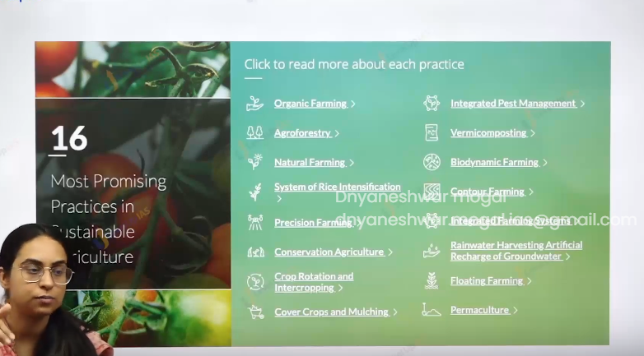

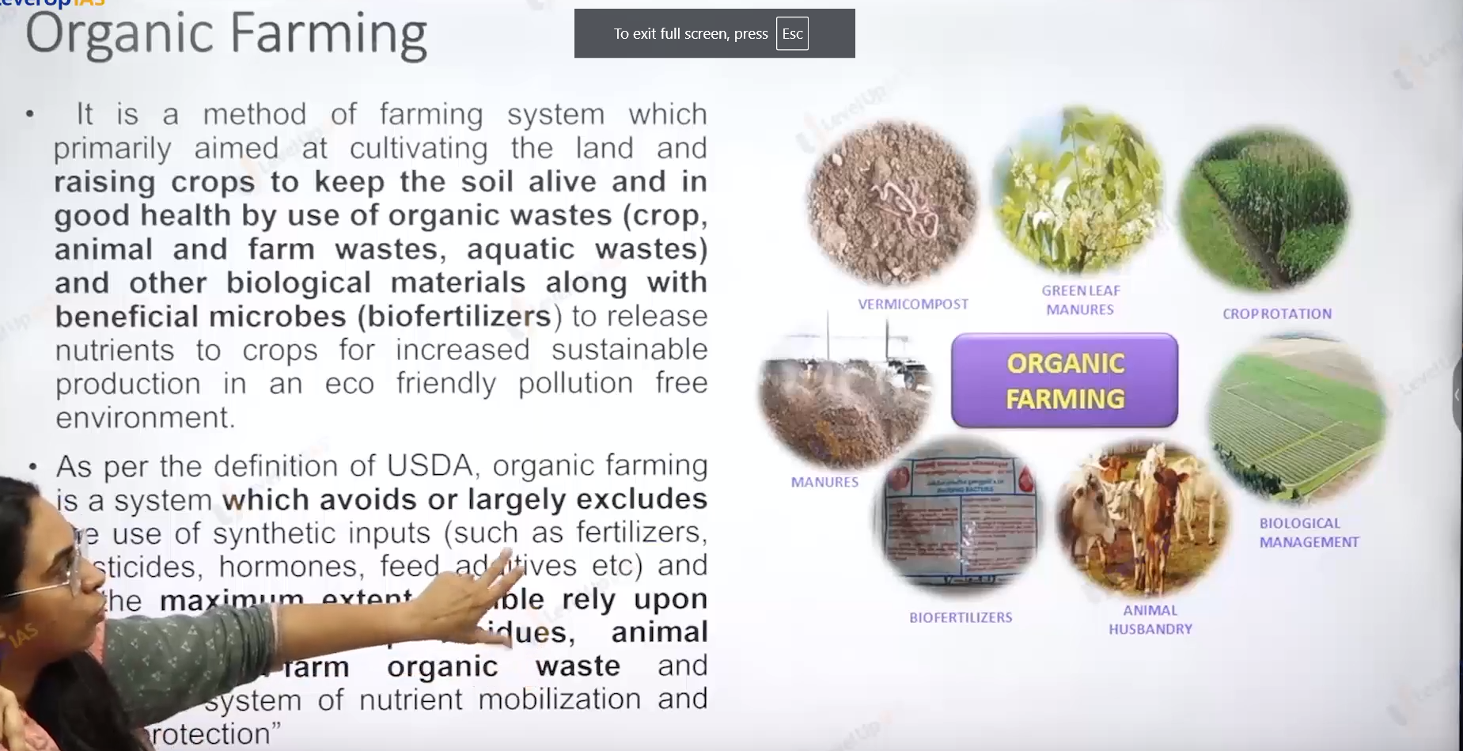

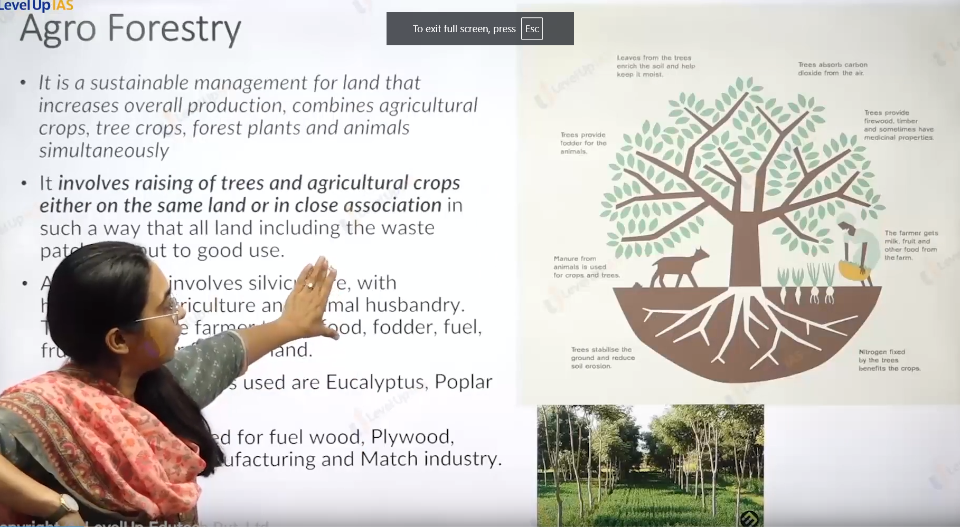

Agroforestry:

1. It is sustainable management for land that increases overall food production by combining agricultural crops and tree crops and forest crops and animals simultaneously.
2. It involves the raising of trees and agriculture crop on the same land such that all the land including waste land is put to good use.
3. Agroforestry involves silviculture, horticulture, agriculture and animal husbandry. This enables farmers to farm food, fodder, fuel and timber from his land.
4. The main species grown are eucalyptus, poplar, tik, Sal.

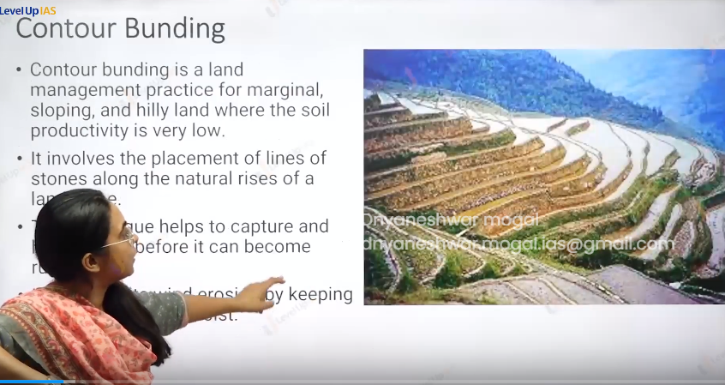

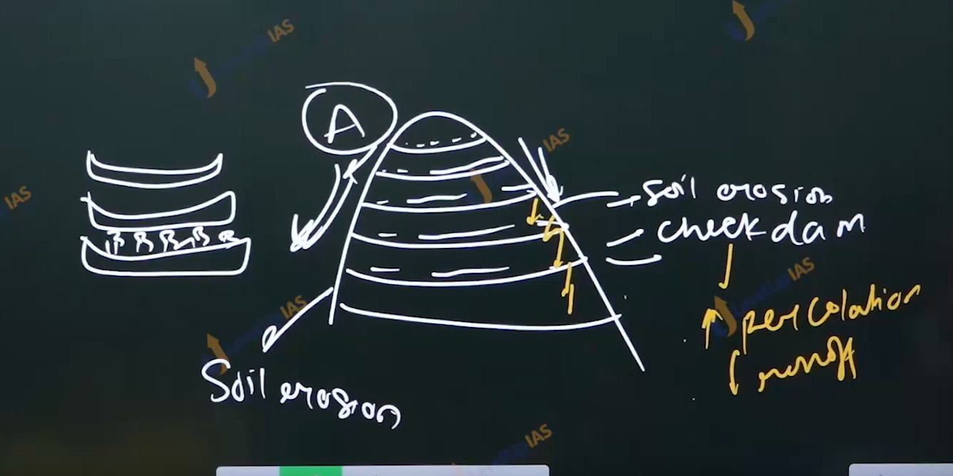

Contour farming:

1. It is land management practices. For marginal sloping and Hilley land where the soil productivity is low. It involved the plowing along the contour lines and rather that plowing along the slope.
2. This technique also helps in the capture and hold rainfall before it can become runoff.
3. It also helps in checking the wind erosion by keeping the soil moist.

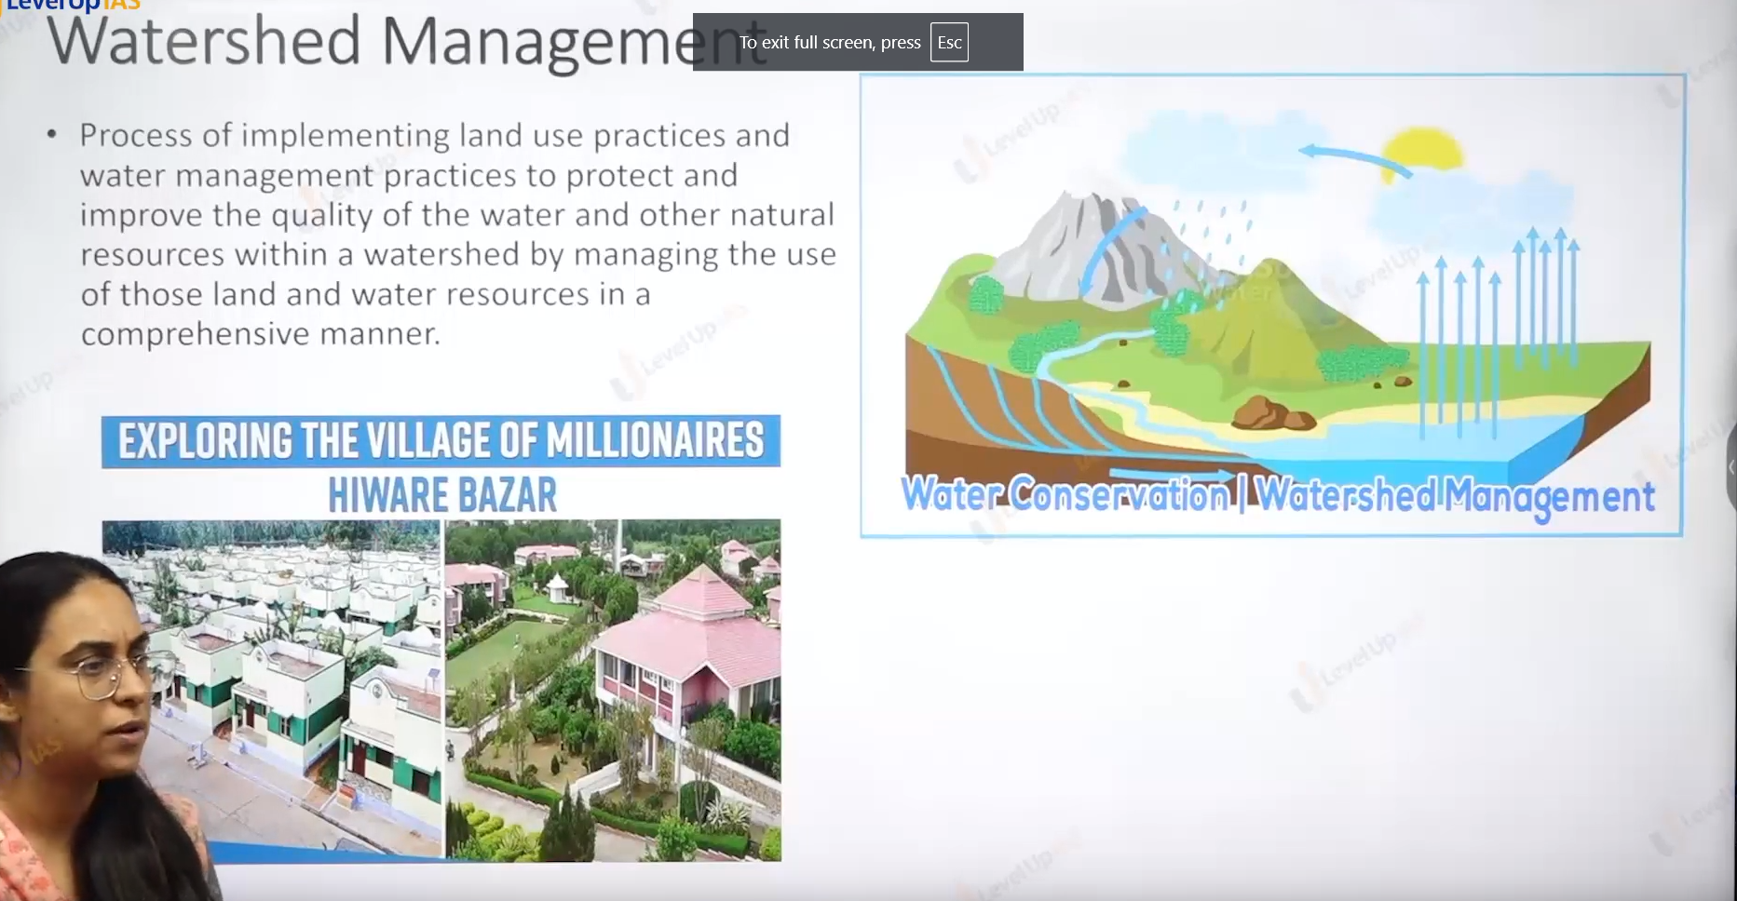

Water shade management:

1. It is of is process of implementing land use practices and water management practice to protect and improve the quality of water and other natural resources by managing the use of land and water in the comprehensive manner.
2. Water shade management plans to utilize the geohydrological unit weather water can reused for planning purposes. It aims to increase the water leaves by following the principles and ecological structure.
3. It aims at conserving the water using rainwater harvesting structure and check dam and improving the ground water by a forestation all this leads to increase the ground water table. And therefore, helps in the reversal of local agricultural.
4. Water shade management is against heavy engineering structures like construction of large dam, interlinking of river relies on ecological solutions.
5. The kind of agriculture is done on water shade-based management is suitable according to climate of the place that is agroclimatic regionalization.
6. Ex. Ralegan Siddhi of anna Hazare, and hiware bazar of popat rao Pawar.

Globally important agricultural heritage site:

1. To understand and appreciate the nature’s friendly agricultural practices local and tribal populations around the world FAO recognizes some agricultural practices as GIAHS.
2. GIAHS helps to document the indigenous knowledge conserver at the global ever to promote the food security and also provides the incentive to local population. To measure like eco labeling eco-tourism.
3. GIASH site is chosen with following considerations Provision of local food security, agricultural biodiversity and indigenous knowledge and management techniques.
4. GIASH SITE in India as Korkut rich biodiversity agriculture where several verities of paddy millet and pulses and oil seed are grown.
5. Kuthanad below sea level rice cultivation. This only system in India.
6. Saffron cultivation in the Pampore.

Conservation agriculture :

1. During past 40 year world has lost 1/3rd of its irritable land. To stop the degradation land and regenerate the degraded land conservation agriculture has been suggested by FAO.
2. It relies on 3 principles
   1. Minimum soil disturbance: 0 or no tillage this reduces soil erosion and preserves the soil organic matter.
   2. Permanent soil organic cover at least 30% of crops cover on the soil it prevents weed growth, protects the soil from extreme weather, preserve the soil moisture. And avoids compactions of soil.
   3. Crops diversification: through various crops sequencing. This promotes the crop rotation better nutrient cycling prevent past and diseases.

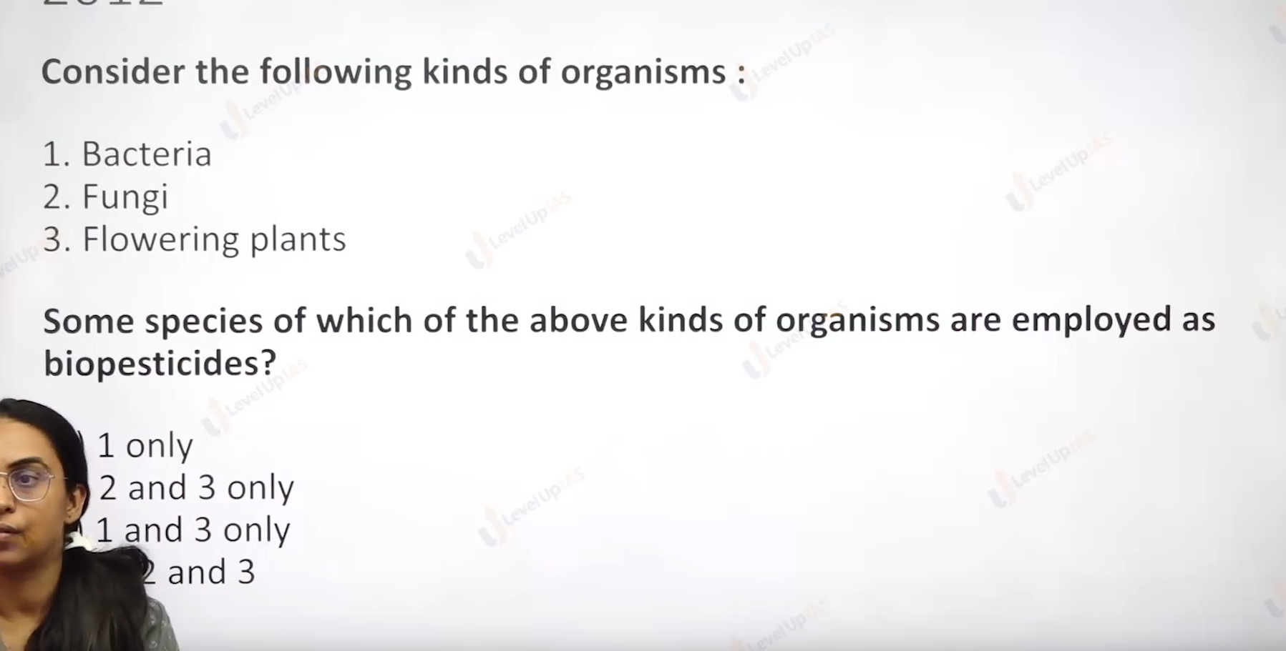

Ans : D all of this above.

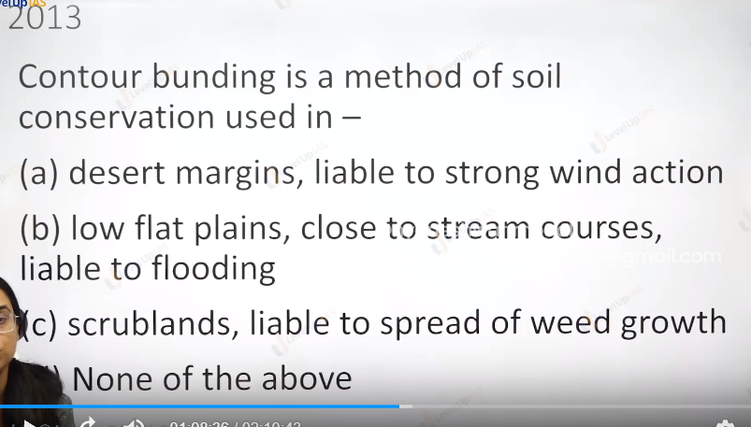

Ans: D

Then we create the wall of vegetation near the desert to stop more desertification called shelter blelt.

To stop flooding on embarkment natural leaves\

Merchanting cover the with the plastic.

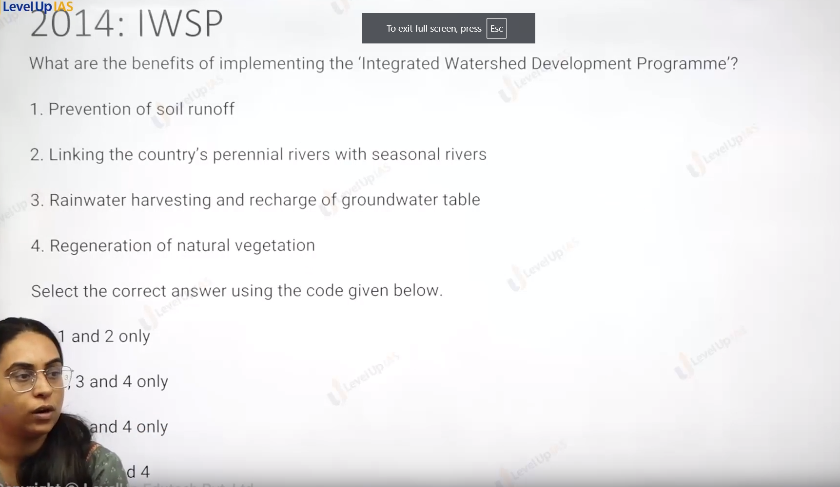

Ans : 1,3,4

Ans is c :



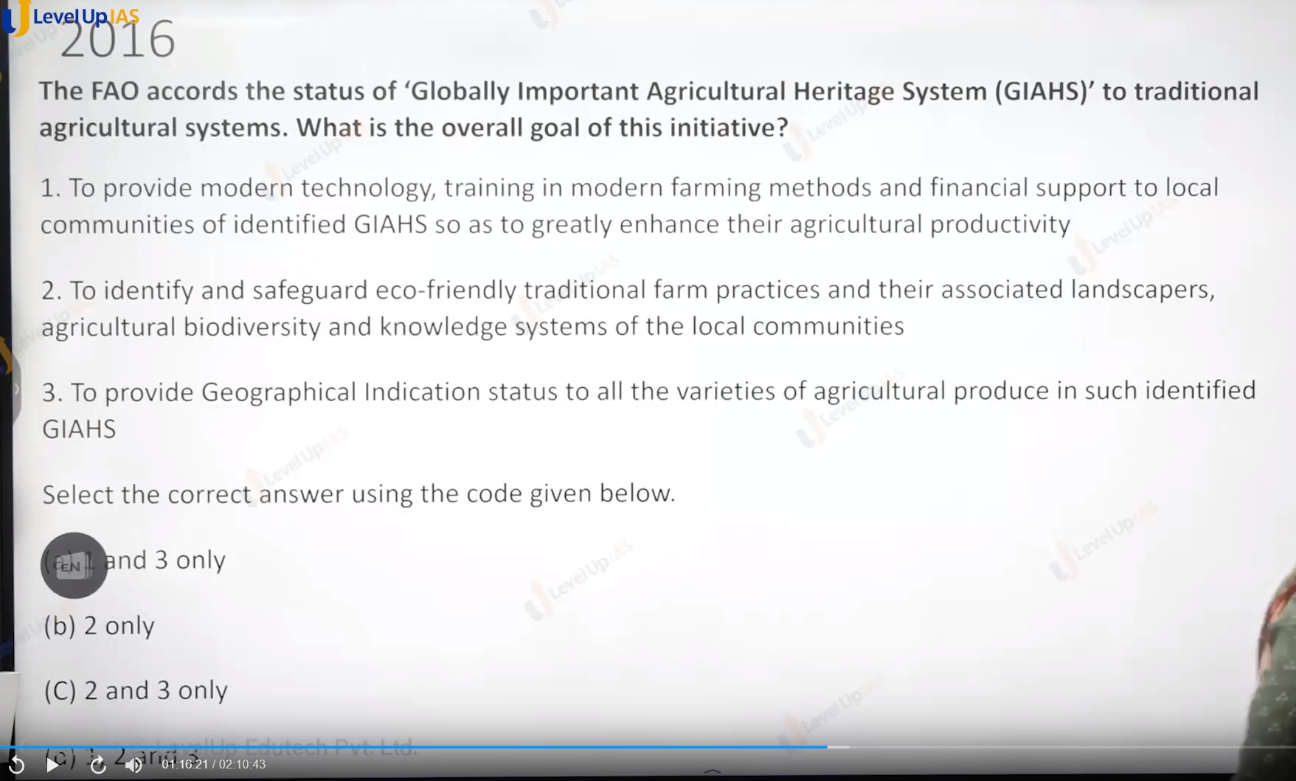

Ans : b

Regarding 3 statement GI tag is exclusive in the nature. Uniqueness.

environment



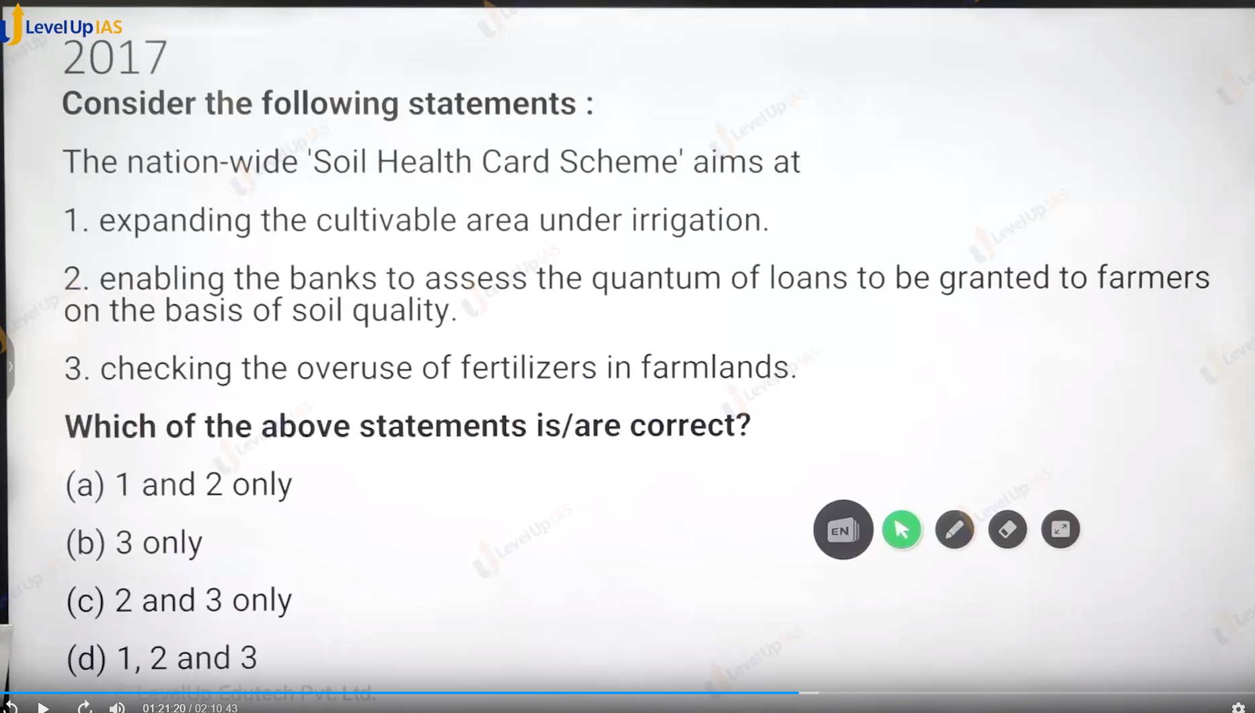

ans is : 3 only.

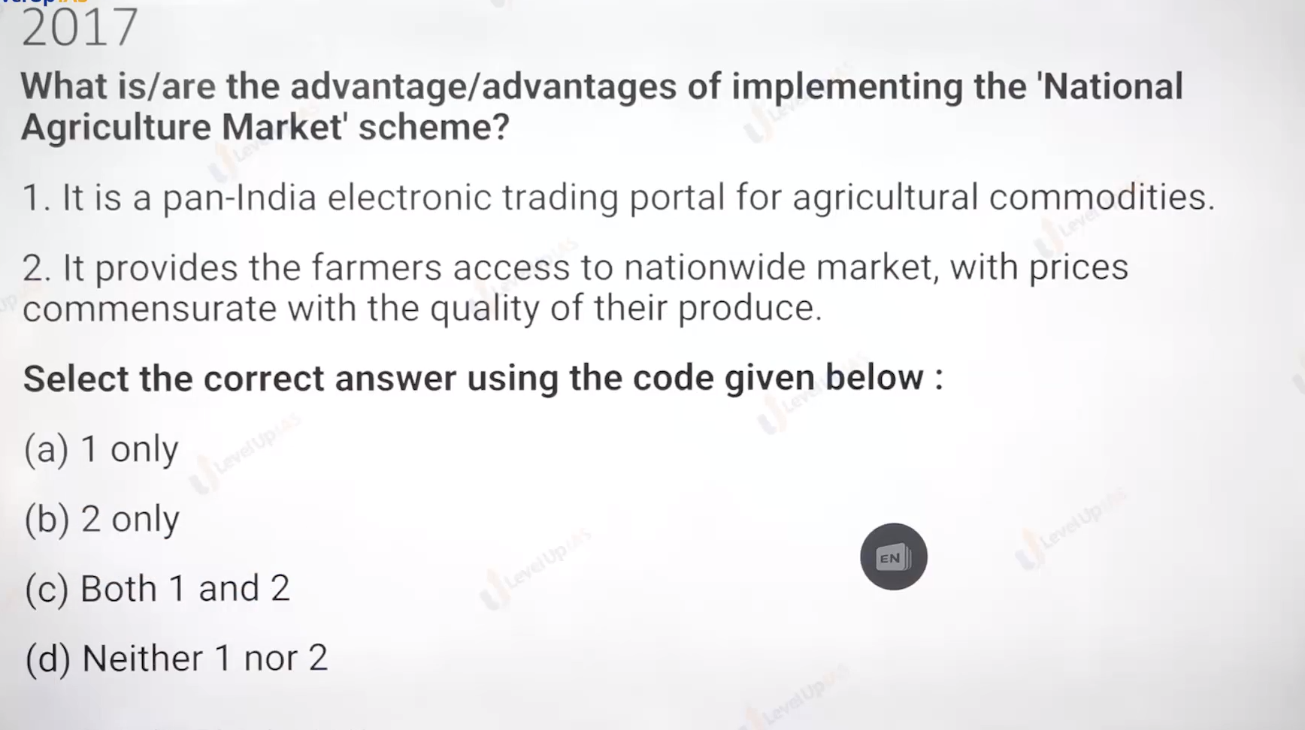  
  
Ans : c both are true.

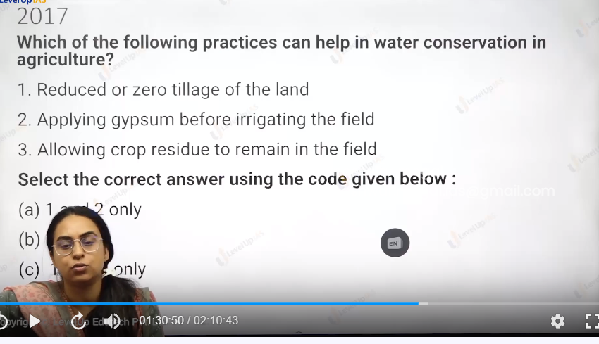  
  
  
  
ans : 1, 3 c

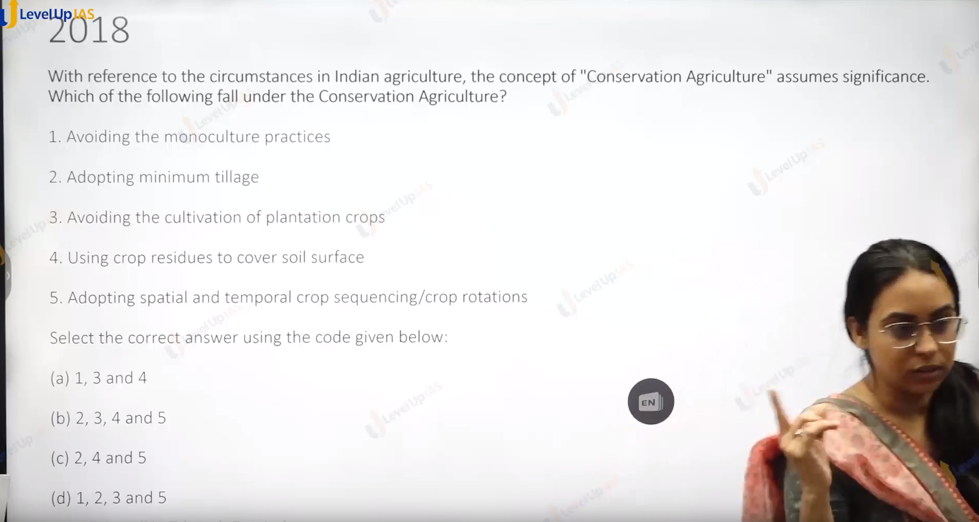  
  
  
ans : c

1. There monoculture or mixing cropping do not related to conservation.

2 Minimum tilt consume the water/nutrient in the soil.

3 plantation no specific effect related to conservation agriculture.

4 crop reside will remails in the soil.

5 crop rotation will conserve the soil nutrient

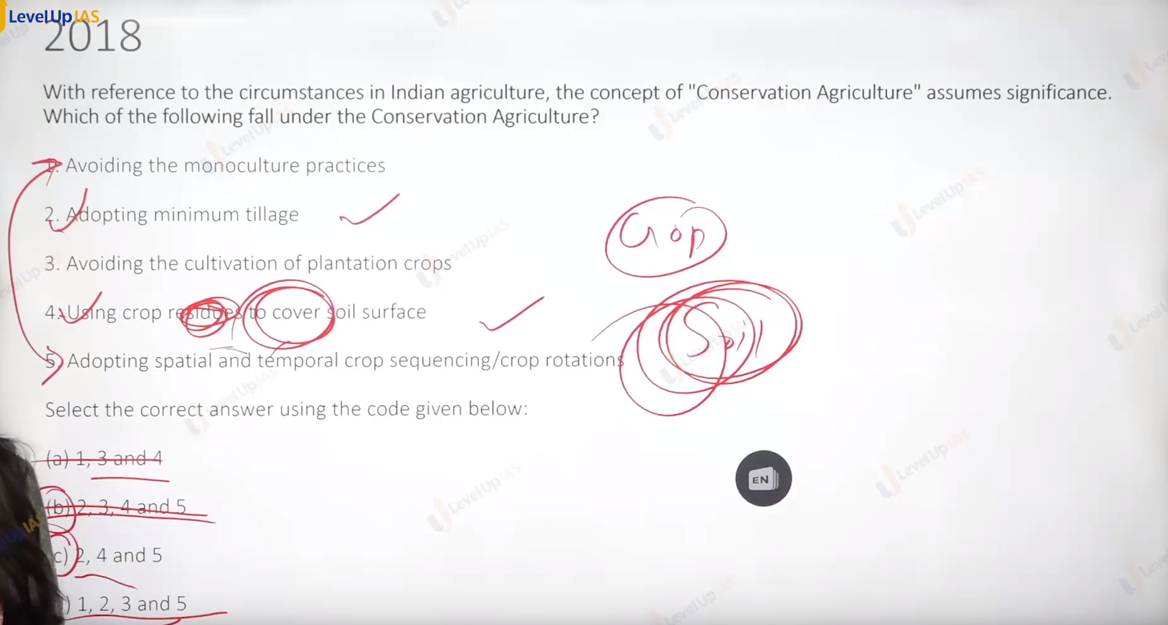  
  
  
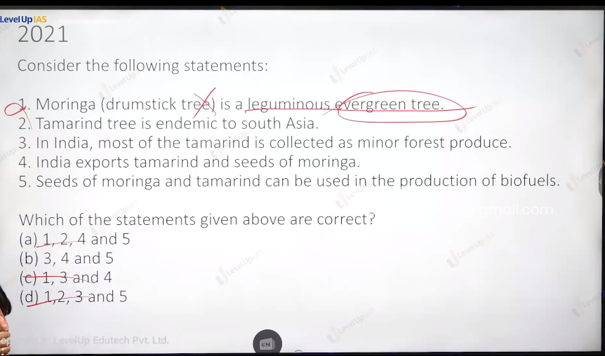

1 is wrong because no evergreen you saw the yellow leaves of moringa, and they shed the leaves all leaves.

So ans is B.

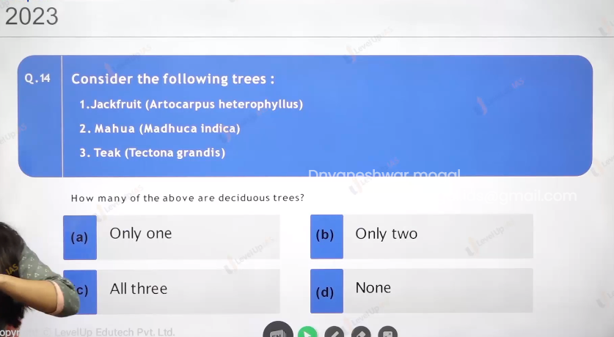

Jack fruit is ever green only found in the kokkan,.kerala.

Only 2 ans b.

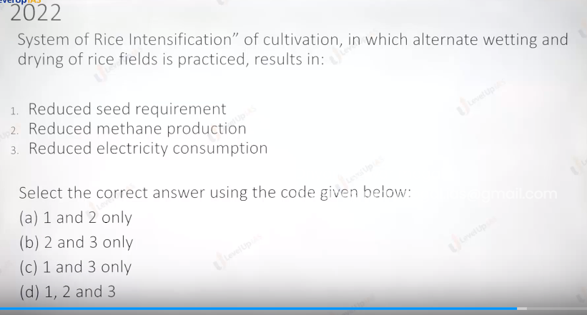

Green revolution:

1. Green revolution was introduced in 1966-67 in the back drop of food crises and famine the external threat drought condition, collapsing economic.
2. A recently independent nation facing food crises leads to tarnishing of international images.
3. India was seeking food aid from the developed world. US provide the food aid to india under PL480.
4. Before green revolution was launched certain pilot, intensive agriculture area program and intensive district program was launched.
5. This program pave the way for green revolution. The aim of green revolution was in the short term to provide the food security and manage huger crisis. With the trust on the adopting the technology (hyv seels norman Borlaug was father of green revolution and had developed the strain of dwarf wheat )
6. In the long term the aim was agriculture
   1. modernization. Use of HYV SEEDS machines the tool irrigation fertilization ,
   2. rural development:
   3. industrial development:
7. As a part of strategy it was aimed at replacing the traditional seeds and introducing the modern technology like HYV seed, dwarf verity of seeds.
8. The nature of seeds was input intensive that is use of water fertilizer and pesticides.
9. Another strategy was deliberate in balance strategy. The focus was on the rice and wheat that is crops specific strategy and the region chosen was western UP, Hayana and Panjab.
10. This region was chosen because this region has history agriculture development, rich famers, large land holding, good irrigation system, ( channels, tubewells.)
11. Focus on rich and large farmers

outcome of green revolution:

positive:

1. Food sufficiency: the production in 1950 50 metric tons in 2021 300 metric tons.
2. Agriculture infrastructure: in the northwestern part of country become well develop
3. Agriculture productivity multiplies 3 to 4 times for most agriculture products.
4. India has large food buffer stock. That runs India public distribution center.
5. In balance

Negative

1. There is crop in balance pulse and oil seed are neglected.
2. Farmer imbalance small and marginal farmer are not benefited much.
3. Regional in balance: dry and rain feed area were not developed.
4. Reason for imbalance is delegate in balance strategy in the short-term imbalance continue failure of trickling down the benefit.
5. Ecological problems: over use of ground water, excessive use fertilizer, monocropping, ground water contamination due to excessive use of fertilizer, land pollution and soil salinization.
6. Stagnation and decline in agriculture, especially in the Green Revolution zone.

Second green revolution (ever green revolution) :

1. revolution that is more sustainable and respects the local climate and local variety of seeds and is based on ecological principles and practices like zero budget natural farming organic farming, integrated farming.
   1. Focus on the small and marginal farmer
   2. There should be focus on climate smart agriculture and conservation agriculture.
2. Special focus can be page trough dry land agriculture. Dry land produces the 40% of India’s food grains and 60% marginal famer.
3. Day land agriculture practices in areas with rainfall area less 100 without the support of off irrigation.

White resolution: (operation flood)

1. 1970 background green revolution is successful, and the problem of hunger is resolves therefore it aim to replicate the success of green revolution to the other crops of agriculture. Like livestock fisher and horticulture. Forestry etc. livestock as form of agriculture diversification is important because India history of mixed forming. It is important for food security to promote alternative lively hood is important buffer in the drought management. (Based for income distribution.
2. Dry land and semi aired region forms nearly 2/3 part of the country these regions have drought problem and repeated crop loss. Small and marginal farmer in this region do not have income support and green revolution as technology is not possible and semi-arid and dry regions so the alternative to have another revolution non crop cattle-based revolution in the form of white revolution.
3. White revolution is not the consequence of hunger crises but inspired by the green revolution.
4. White revolution was launched to create the cattle economy and to increase the milk production under the co-operative organization therefore the aims was
   1. Enhance the milk production
   2. Undergo agriculture diversification.
   3. Development of dry and agriculture regions
   4. Benefit small and marginal famer.
5. The strategy was improving the bridge of cattle by hybridization.
6. Scale up the production by procuring the milk from the cattle owner rather than middleman.
7. Scale up the processing of milk by setting the common processing unit like chilling plant refrigerator.
8. Whole set was the function of multitier co-operative organization:
   1. Primary village cooperative
   2. District co-operative
   3. State level co-operatives.
   4. National level co-operatives.

Outcome:

Positive:

1. It is one of the most successful programs, India is largest milk producer in the world.
2. There is significant increase in per capita availability milk in the country. 250 grams per day in 1950 to 400 grams per day in 2020.
3. The small and marginal farmers have benefited the most as about 37% of milk comes from small and marginal farmers.
4. Dairy industry and infrastructure have been modernized to offset seasonal and regional variation. In milk production.
5. Genetic improvement of the Milch cattle has been possible by cross breading.

What more is needed:

1. Encouraging the local breeds like gir, Sahiwal, devni, red sandhi, Amrit mahal.
2. Increase fodder production and pastureland.
3. Address the low productivity by keeping the cattle in the hygienic condition. Export the market for milk products need to tap.

Blue revolution:

1. It aims to utilize the fishery sector crab, mulask, prone, shrimps,
2. In India there is large potentials of fishery sector. India has long coast line 7516 km . India has 3 million sq km Exclusive zone. India has broad continental shell, large rivers ponds, lakes.
3. India has greater than 18 thousand species of the 30 species I the world. India is 3 rd. largest producer of fish. Some of fish species are Mumbai duck, Indian Salman, salmon, rohu, Katla, makral, sharks, etc.
4. Blue revolution has been corned by the capitalist,

Blue revolution:

1. It started in 1980 after the successful of green revolution. It aims to increase the fisheries by promoting fishing in the natural bodies like river channel and in the marine environment.
2. Also increase the fishing production in the aqua culture system. Like artificial tank using brackish water( it this component that dominated) . To tap the international market.
3. Strategies of blue revolution was used of modern infrastructure, like motorized boat big trawlers for fishing processing of fish. Utilization of cold storage facilities

Outcome:

1. Outcome has been fish industry underwent transformation under traditional style to multicore industry.
2. Industry has been dominated by the capitalists has technology is very expensive and needs large investments.
3. Thow the fish production has been improved, especially in the inland fishing and brackish water, aqua culture, deep sea fishing is almost non existing. Only 10 to 20 percent has been taped.
4. Brackish water aqua culture also has environmental issue like pollution, exposing the coaster area to erosion
5. Blue revolution has not benefited small and marginal farmer.
6. Marine fishing has been untap due to lack of remote sensing-based tracking technology lack of modernized fishing boat, lack of refrigeration facilities,
7. in the developed countries like China, Japan and Korea, fishing ship remain the water for 6 months. Such fishing units have processing units from where the export can be made.

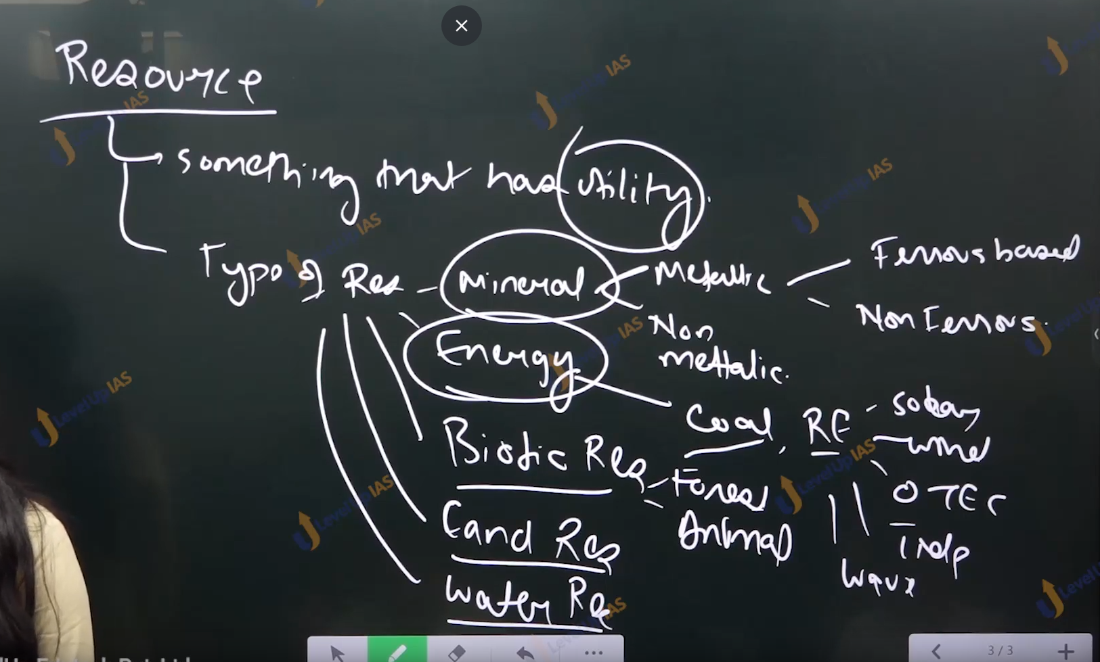

Resources:

1. India has around the 90 95 type of mineral resources.
2. Some major minerals are gold, silver, iron ore, nickel, tungsten, copper,
3. Some nonmetal minerals, limestone gypsum.
4. Some fuel based mineral resources uranium thorium,
5. Minerals are important for industrial, regional development, employment development, they are basis for development of core industries, like cement, crude oil, coal, electricity, electricity fertilizer, natural gas, refinery production, Steel etc.
6. The major minerals belts in India are located in in the tribal belt therefore same resources which could have been used for tribal development has now become the resource cause.
7. Rare earth minerals: they are not rarely found but they are found in the less concentration and therefore it difficult to mine them economically.
8. At present China controls the majority of production followed by the USA,
9. EX. Yttrium, scandium, and lanthanide series, they are used in the production of atomic energy and lesser technology, solar energy batteries, space sector, telecommunication,